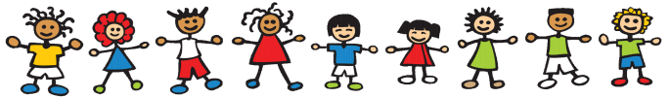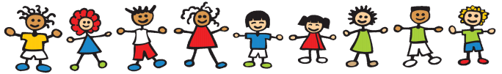

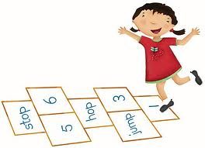

Mathematics

I will have the chance to sort and group objects or materials and explain why I have done this. I will be able to play with lots of resources indoors and outdoors and make comparisons in things like height, weight, size and texture.

I will be able to use words like under, on top, between and in front to tell where things are and to put things in order when I play. I will have opportunities to build and make things with shapes and talk about what these shapes look like.

I will be able to use numbers when I play to count and match things to each other. I will begin to learn about adding things together or taking them away. I will learn to recognise numbers all around me and use them confidently in play and games. I will start to be able to put events in order and think about what happens next during the day. I will get the chance to notice patterns in lots of situations and have a go at making patterns myself. I will get to use all I know about Maths to solve practical problems when doubling, halving and sharing.

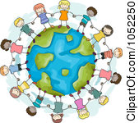

Understanding the World

Having plenty of time indoors and out I will be able to look at and talk about objects, materials, living creatures and plant life, noticing lots of details and things that are the same or different. I will be able to take part in explorations and investigations at all different times of the year in the classroom and in the outdoor environment giving me the chance to notice changes as time passes. I will have the chance to make predictions, try things out and come to some conclusions and even give some reasons as to why I think things happen. I can share these discoveries with friends and sometimes I will record what I see and find out by drawing, writing or using a camera or computer.

I can also find out about things we use every day in the home and at school as well as places and buildings in the area I live.

I will be able to talk about special moments and events I have shared with my family and things I am looking forward to. I will begin to know more about different people and their cultures, traditions and places in my community.