

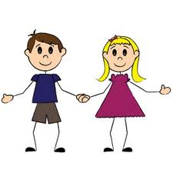

Personal, Social, Emotional and Development

During my first year at school I will be developing my confidence and self-esteem, my ability to be assertive and stand up for my own rights or ask for adult support. I will be learning about relationships with both adults and children, making particular friendships and learning to share, to take turns and to negotiate with others.

I will begin to understand rules, to empathize with others and to learn about differences I may see in cultures, religion or language. I will develop the ability to express my feelings, to control them where appropriate and to express any anxieties to others. I will develop my independence in looking after myself and my things, choosing what I would like to do, finding what I need, planning my time, thinking of and acting on my own ideas and asking for help if I need it. I will be able to take responsibility for tidying up, helping younger children, taking messages and carrying out a task. I will learn to be pleased with and be proud of what I can do.



Communication and Language

I will be able to talk about what I want and how I feel and will have opportunities to express this through role play. I will be able to enjoy stories, poems, songs and rhymes, and will develop the ability to use language to describe past and present experiences and a sequence of events. I will develop my ability to question experiences and events and supply logical explanations or predict what might happen next. I will have the chance to talk imaginatively and retell stories in my own words. I will learn to speak to others in small and large groups and share my ideas and thoughts with them. I will learn to listen to others and ask interesting and appropriate questions.

I will learn to follow a set of instructions and be able to answer ‘how’ and ‘why’ questions about my experiences.