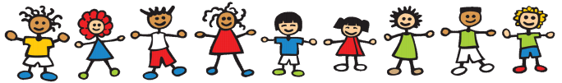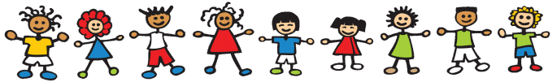

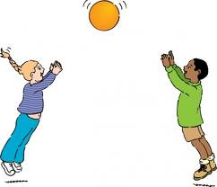

Physical Development

There will be lots of time for me to play and learn inside and outside the school. I will get the chance to become good at moving, climbing, controlling and coordinating as I play. I will have fun with my friends and teachers learning to use my body, my feet and my hands with more and more skill. I will get to use lots of outdoor toys to ride on, throw, catch, climb on and build with. I will be able to chase, race, jump, balance, play on my own and begin to play with a partner or a group or team.

When I am busy and active I will be able to feel the changes that take place in my body. I will be able to find out and talk about what helps to keep me fit and healthy and what food is good for me. I will learn to get my coat on or fasten my shoes so that I can look after myself.

I will use lots of tools for drawing, painting, cutting, woodwork, sewing, cooking, joining and dismantling as well as other equipment for building, threading, dressing dolls, creating tents, dens and structures and playing sport.

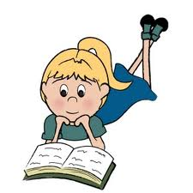

Literacy

Through handling books and sharing them with others, I will recognise that words tell stories and that the words I see in the world around me tell people something. I will get the chance to see letters and words written down and to try and write them myself and use them when I play. I will learn the alphabetical sounds and through a mixture of speaking and listening I will start to hear the different sounds that make up a word. I will apply this knowledge when looking at words in books and will begin to read and write sentences and captions. To support my learning I will have access to multisensory story sacks, matching word and picture games, bingo games and will have frequent opportunities to use the computer. I will have the chance to read on my own, with the support of my teacher and in small groups on a regular basis. I will have fun using words to talk, read and write.