CORONAVIRUS PANDEMIC (Covid-19) - UPDATE

12th May 2020

Following the announcement by the Prime Minister on 10th May and initial further guidance published by the Government on 11th May, we expect to receive further details from the Department for Education on how schools can begin to accept more pupils into classrooms safely.

Everyone at Lingfield Education Trust is committed to ensuring that the safety and welfare of pupils and staff colleagues is the most important aspect of the work that is now underway to develop plans for this initial return to school.

The Trust will follow the detailed guidance and advice when it is published by the DfE. We will endeavour to ensure that all our schools and staff are ready to provide a safe, clean and healthy environment and that the latest advice on hygiene, social distancing and infection control is followed.

Schools hope to be in a position to welcome back children into Nursery, Reception, Year 1 and Year 6 from Monday 1st June, in accordance with DfE guidance, provided it is safe to do so. Head Teachers will notify parents and staff colleagues when these plans are confirmed. It is likely that pupils returning will be taught in smaller groups and at different locations than their classrooms before the lockdown began, and possibly with a different teacher.

Until then, arrangements will remain as they have been in previous weeks, with places at schools provided for the children of critical workers and those pupils who are vulnerable.

Lingfield Education Trust will continue to ensure this website, and those of its schools, are updated as plans for re-opening develop. Thank-you for your ongoing support at this time.
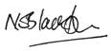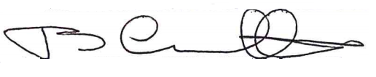

Nick Blackburn Stuart Crowther
CEO Chair of the Board of Trustees
Lingfield Education Trust Lingfield Education Trust

