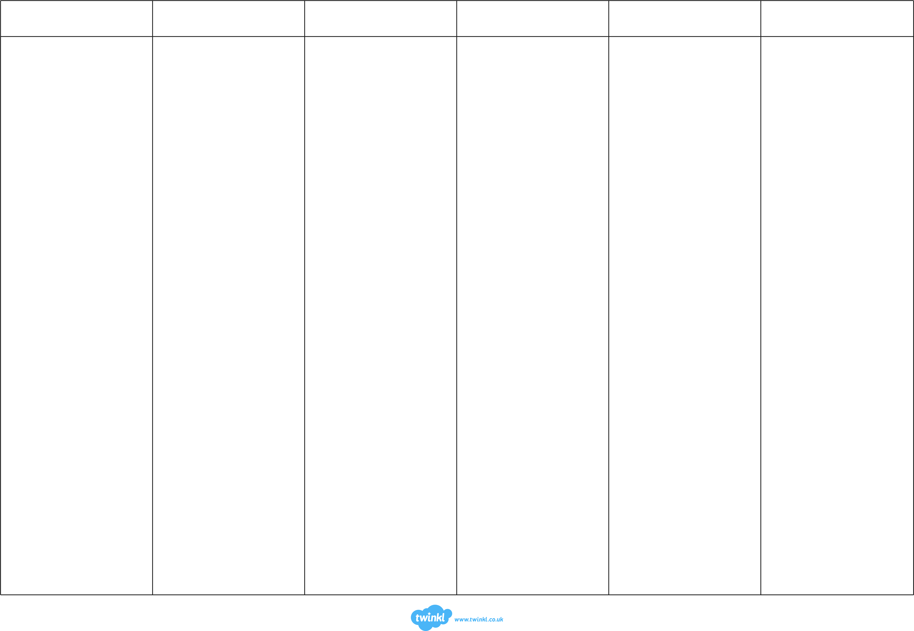
Reading Focus 2
Reading Focus 3
Reading Focus 4
Reading Focus 5
Reading Focus 6
Reading Focus 7
Why do…?
Which word told you that…?
Which paragraph tells you…?
Which character…?
Where did…go?
Where are…?
Where and when did the story take place?
What was happening at the beginning of the story?
What is ‘animation’?
What happened in the story?
What does…mean?
What did…do?
True/False based on text.
Match answers from text evidence.
Identify a word from paragraph 2 which shows that…
How many…?
Give one example…
Find some words or phrases that tell you about the setting.
Find 3 words that describe your favourite character.
Who are the key characters in the book?
Describe…
Can…have more than one meaning?

How did the characters’ feelings change?
How did…?
How are the experiences of these two characters similar?
Who would you like to meet in the story and why?
What evidence is there that…?
If you made a movie of this story, what type of music would you use for it and why?
What is your favourite part of the story and why?
Why did…?
What impression do you get of the feelings of this character from the text?
What does the word…imply about…?
Based on evidence from the text, what would you buy / do / see / ask?
Why did he feel…?
What might this character have been thinking?
How did the character feel before…and after…?
What questions would you ask your favourite character?
Why did…?
What does this quotation suggest about…?
What does… think?
What ideas are we given about...?
What words tell us…?
What is this character’s attitude towards…?
What do you think is going to happen next?
How did…react?
What do you think the story is going to be about?
How was…different after…?
Why is… important?
Explain the use of the word…

Why is it easier to read…?
Why did the author choose to…?
Why has…?
Why are… used?
Why is… in…?
How does the layout help…?
What is the purpose of…?
Give two features that tell you it is written as a formal letter/diary/script.
What would be a suitable heading for this text?
Why does the author use…?
What would be a suitable caption for this image?
Why is this element in bold/underlined/in italics?
How does the timeline/image/diagram/layout make it easier to understand?
Label these parts of the text.
Sequence these events from the text.
How does the writer build up to the conclusion?
How does the writer link the conclusion to the introduction?
How does this paragraph link back to the opening paragraph?
How does the first sentence help to guide the reader?
Why are some sentences shorter than others?
Why is the text organised in this way?
How many paragraphs are on the page?
What does the glossary tell us?

Underline the word/noun/verb/phrase which shows that…
Why did the author use…?
What is the effect of…?
Explain how the use of language in this sentence shows…
Why is the word…in inverted commas?
Why is this style of formal / informal language used in this text?
Why does the writer compare… to…?
Can you find any amazing adjectives?
What does the choice of language suggest…?
Can you find any powerful verbs?
Why does the writer use the word…?
What words help the reader to imagine…?
What does…tell you about…?
How does the choice of language create the impression that…?
How does… help you to understand?
Which phrase best describes…
What do phrases such as…tell you?
Which part of the story best describes the setting?
Why did the author choose the verbs…and…?
Explain why… is used.
In what way is…like…?
Which parts of the text tell you…?
How has the choice of words created a feeling of…?
Why are… used?
Explain two ways in which this sentence makes the reader…
Choose a word to describe this character and explain why you chose it.
How does the author make you want to continue reading the story?
Why is the description of…a good metaphor to use?

Which elements of this text are persuasive?
Why does this section begin with a question?
What do you think the writer thinks about this topic and why?
Why were…included?
Can you think of another story that is similar to this one?
Does the author like…? How do you know?
What kind of magazine would you expect to find an article like this?
How were the purposes of the texts different?
How does this article create the impression that…?
What can you tell about the viewpoint of the author?
How does the author make you feel?
What is the main purpose of this text?
How does the author make you feel…?
Was there any part of the story you didn’t like and why?
Which of these texts would inspire you to…?
Look at the descriptions of 3 people. Who is most likely to buy this book?
Which text is…?
How would you start this story?
Was this text trying to…?
How does the writer show their positive/negative attitude towards…?
Which text do you think is more/most effective?
Why do you think the author chose this setting?
Why has the author included…?
How can you recognise the attitude of this character?

In what ways is…like…?
How would you describe this story?
How did you know…?
What did the story make you think about?
What is it about…that tells you…?
Which features could…have?
What other stories have you read by this author?
Where do you think this story is set and what made you think that?
Have you been in a similar situation to the character in the book?
What else might make…sad / angry?
Why does…ask… to…?
Give two pieces of evidence that…?
What other reason could there be for…?

