. |  | Autumn 1 |  | Autumn 2 |  | Spring 1 |  | Spring 2 |  | Summer 1 |  | Summer 2
Base 1 |  | Mr Wolf stories  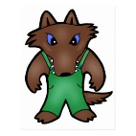 |  | The Gruffalo/The Gruffalo child  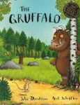 |  | Dinosaurs 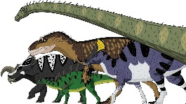 |  | Traditional Tales  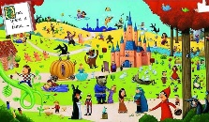 |  | Minibeasts  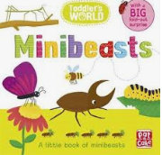 |  | Seaside  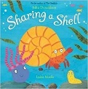
EYFS |  | 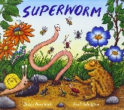  Superworm and Oi Frog |  | Where the wild things are/The Gruffalo/The Gruffalo child |  | Traditional Tales |  |  |  | The three little pigs, goldilocks and the three bears  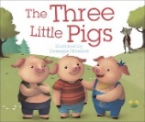 |  | Oliver Jeffer stories  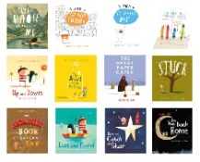
Year 1 |  | Dinosaurs |  | Toys R Us  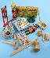 |  | Katie Morag  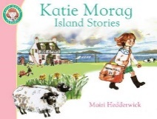 |  | Kings and Queens  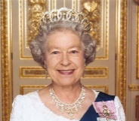 |  | Animals Around The World  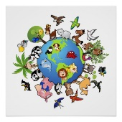 |  | Wildlife Garden  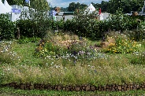
Year 2 |  | London’s Burning  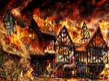 |  | Parliament - Guy Fawkes |  | Kenya  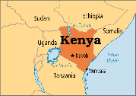 |  | Rolling Over the Ocean (Captain Cook)  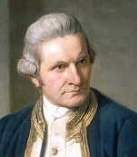 |  |  |  | Wildlife garden  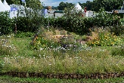
Year 3/4 & Base 2  Cycle A |  | Land before time  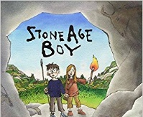 |  | Tremors  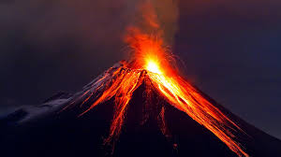 |  |  |  | The Boy King  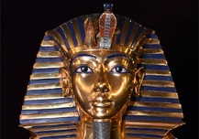 |  |  |  | Rainforests and Rivers  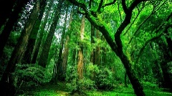
Year 5 |  | World War 2 |  |  |  | Around the World |  | Meet the Greeks  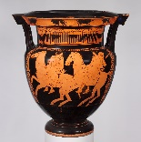 |  |  |  | The French Connection (1066)  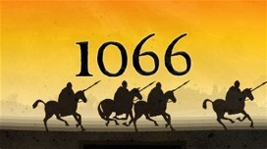
Year 6 |  | Shaking All Over  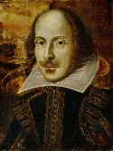 |  | Food Glorious Food  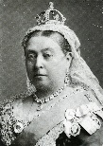 |  | Tomorrow’s World |  |  |  | Land of the Rising Sun  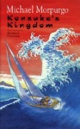 |  | Food of the Gods (Mayans)  