Reading is at the heart of our curriculum; being able to read is one of the most important life skills required for any individual, therefore we ensure that it is a primary focus of our curriculum from Early Years to Year 6. Not only does this include fluency and good comprehension, but also the development of reading for pleasure so that our children flourish into life-long readers. Research links reading not only to academic success, but also success into adulthood and to good mental health – by sowing the seeds of ‘good reading’ now, we are building a strong foundation for our children as they continue to grow and learn.

**Within our broader English Curriculum planning, our intent for reading is clear:**

* Credible, rich, engaging texts from a range of genres are the key driver for the English Curriculum, which promote a love of reading and act as excellent models for language, cultural broadening and confidence.
* Children become fluent and age appropriate readers across Early Years and Key Stage 1 to enable them to access and comprehend all that Key Stage 2 has to offer, including the continued development of a growing vocabulary.
* Children reach the expected standard in Year 1 phonics with word reading fluency being the primary driver of the Year 1 Reading Curriculum, enabling them to gain greater comprehension skills across Year 2 and beyond.

**Phonics**

We are resolute that only children with specific special educational needs cannot learn the phonetic code, therefore we expect almost all children to learn to read through clear and progressive phonics teaching.

Our phonics teaching is intensive, and follows the programme of ‘Letters and Sounds’. We begin teaching phase 1 to our children in Nursery through play, rhyme, circle time, group activities and various innate opportunities throughout the session via oral segmentation. Direct phonics teaching starts as soon as our children enter Reception – no time is wasted.

In order to ensure that all staff deliver high quality, purposeful and well-structured phonics teaching, not only do new members receive phonics training but existing members receive annual refresher training. We also provide training for all volunteer readers (such as governors) to ensure that the support they provide is in line with our school approach and directly promotes the application and consolidation of what has been learnt.

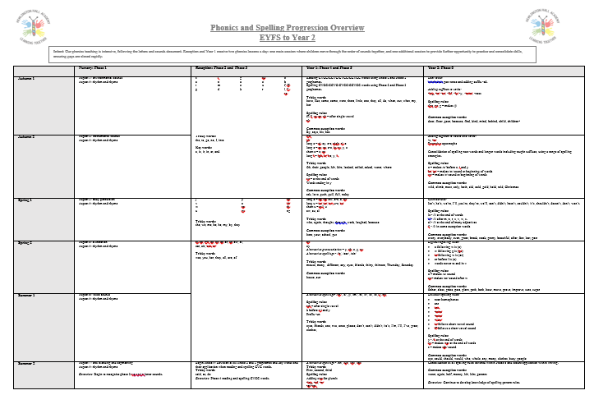Further to this, we ensure that the books children are given to read at home are closely matched to the sounds which have been taught in school so that children do not encounter words which they cannot decode; this is through the ‘Bug Club’ scheme (which directly matches the ‘Letters and Sounds’ progression, and provides additional resources to support the systematic teaching of phonics). As children become more confident readers, carefully chosen books also include ‘common exception words’ which children have been taught.

We expect children to read *at least* three times per week at home, which should be recorded in their individual reading diary. Children are provided with two books each week, including fiction and non-fiction selections. Children who do not read at home or who are identified as at risk of not making their expected progress will be provided with additional reading opportunities with an adult in school.  
  
Children in Reception also have ‘sound cards’ sent home each week to practise with at home – both in saying the sound, and in blending sounds together. As children become more confident, common exception words are also sent home to practise. Parents are provided with training and support across the year as to how to do this effectively.

**Phonics Teaching Approach**

It is vital that the teaching of Phonics is systematic and the expectations are clear. Of the 26 letters and 44 phonemes there are approximately 140 different letter combinations which children need to learn to become fluent readers. To ensure the effective teaching of Phonics, our approach includes the following:

* All children in Reception and Year 1 receive two phonics lessons a day: one main session where children move through the order of sounds together, and one additional session to provide a further opportunity to practise and consolidate skills.
* Any extra support an individual requires to ‘catch up’ is prioritised between sessions to ensure that learning gaps do not appear nor widen over time.
* The teacher is responsible for the teaching of phonics to all children; well qualified teaching assistants support the teaching and intervention, but the teacher has responsibility for the learning of all children.
* Children’s growing phonics knowledge is closely assessed and tracked through the school’s gap analysis to ensure clarity in their strengths and areas for development. Home reading books are matched accordingly.
* Children apply new sounds learnt straight after being exposed to them, ensuring strong links are forged between phonics, spelling and letter formation and enabling successful spelling into Key Stage 2.
* Phonics teaching includes high frequency words and common exception words to develop children’s sight vocabulary.
* Creative and imaginative teaching approaches, such as a multi-sensory approach, are encouraged.
* Children develop speed in reading over time through secure phonics knowledge and good sight vocabulary so that they do not have to solely rely on decoding, preventing them from ‘losing the flow’ of a sentence.
* Phonics learning is strongest alongside parental partnership, therefore all children are provided with home reading books, sound cards and access to additional resources on the school website. Parent workshops and support are provided all year round.

**Phonics Year Group Expectations**

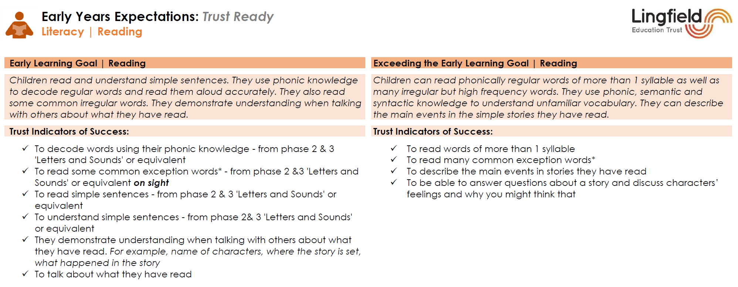**Reception** - The end of year expectation for children’s phonics ability is to be secure in phase 3 with children accessing Phase 4 on exiting Reception. Staff provide children with wide and varied opportunities to play with and explore sounds whilst developing core listening and sound discrimination skills which are imperative for reading and writing success. As part of the Lingfield Education Trust, we further use the ‘Trust Ready’ Curriculum for the Reading Early Learning Goal to set clear expectations.

**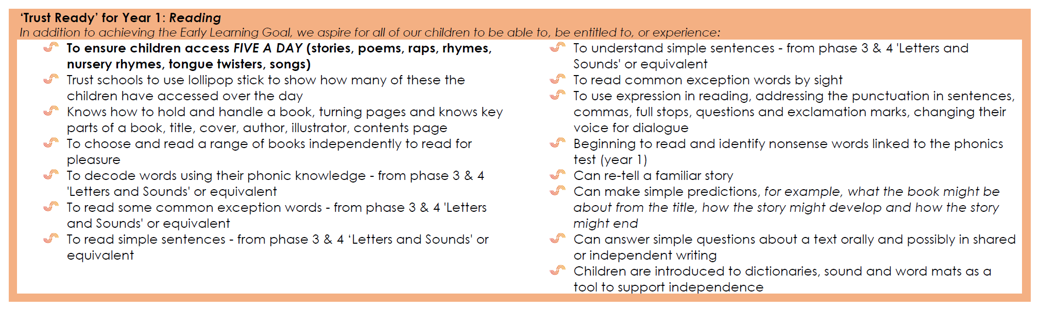  
Year 1** - Children are expected to begin Year 1 at Phase 3 with an end of year aspiration of Phase 5. Aspects of Phase 6 are also covered in accordance with our Trust reading and writing objectives (the prefix ‘un-’ and simple unchanged suffixes such as ‘ed-‘).

**Year 2** - Children are expected to enter Year 2 secure in Phase 5 with an end of year expectation of Phase 6. This is strengthened through consolidation and deepening of all previous phases alongside new teaching due to the variety of rules and alternatives, alongside grammar work in the teaching of aspects such as prefixes and suffixes.

**Progression in Fluency**

In order to become fluent readers, children must master the appropriate phonic sounds detailed in the phonics overview. However, in order to continue to develop as fluid readers, word-reading skills (as outlined in the National Curriculum) are taught in every year group.

For children who did not pass the Phonic Screening Check in Year 1, or Year 2, it is vital that intensive decoding work continues. Children who commence Key Stage 2 unable to meet the demands of the Phonic Screening Check, cannot access age appropriate text within the English and wider curriculum and this must be catered for appropriately across the full curriculum alongside intensive intervention such as Toe-by-Toe.

**Wider Reading Across the School**  
  
To grow children into lifelong readers, teaching must extend beyond Phonics: comprehension, inference, an understanding of language, a widened vocabulary and good reading habits are essential ingredients for successful reading in its truest form. To achieve this, real books are at the heart of our curriculum: our contexts for learning are driven by a wide range of texts; each class enjoys dedicated STAR time (Sit Together and Read) regularly throughout the week; children have opportunities to visit our two school libraries; and children have access to additional opportunities such as ‘Reading Rocks’ library club, author/illustrator workshops and celebration days. The value of reading as a shared experience is given high priority.

This begins in the Early Years, where we ensure that children experience *at least* five language-rich experiences every day (for example stories, non-fiction books, rhymes or songs). Across the Reception year, children have the simple homework of reading their reading books and practising sounds in isolation in addition to blending. In combination, this develops each child’s understanding of story, rhyme, performance, vocabulary and background knowledge.

Subsequently, high quality books and texts form the core of both the English curriculum and the context for learning in the foundation subjects, creating an immersive and joined-up learning experience which develops both reading and vocabulary. Children experience the explicit teaching of reading primarily through whole class reading sessions, which explore texts in detail and develop specific reading skills (as outlined in the Trust’s Reading Standards), and additional guided reading sessions to further support, challenge and consolidate where required.

To continually develop reading for pleasure, each classroom has a dedicated space to provide children with a range of leisure books – a selection of both fiction and non-fiction – that provide children the opportunity to explore genres, styles and formats and to develop their own personal preferences. This is further available through the huge catalogue available in our two libraries, which is regularly added to based on requests from the children and gaps identified through auditing (and which also includes ‘dyslexia-friendly’ books and books of high interest/low reading age to cater for all individuals).

**Comprehension Progression and Teaching**

Children will also experience explicit teaching of reading skills and knowledge throughout school, through whole class reading sessions. These sessions are designed to explore texts in detail, developing children’s comprehension, vocabulary, inference and deduction skills.

These lessons ensure that progression in comprehension skills and knowledge are taught effectively across the school. This progression extends beyond the National Curriculum and has clear year group expectations in relation to the ‘Content Domains’ for reading. Using the appropriate text, year group and content domain foci, teachers plan lessons and activities to meet the specific foci of the Reading Progression expectations.

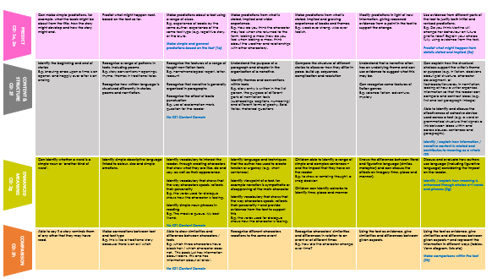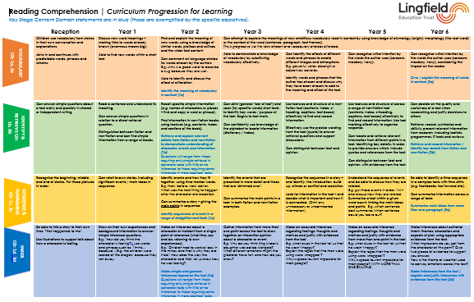

  
**Organising an Extended Response**

As children progress through the reading curriculum, their written comprehension responses become lengthier and require strong evidence. In order to achieve a consistent approach to this, we use the following approach: PEE.

This approach is developed through explicit teaching, so that children gain confidence and experience in organising an extended comprehension responses, rooted in evidence that is cited appropriately from the text.

**Assessing Reading**

We continually assess children’s reading throughout school – not only in terms of phonic sounds, but global reading skills – using a combination of the Trust’s Reading Standards, benchmarking and the NFER Reading tests in Key Stage 2. This provides staff with a wealth of information regarding reading age, comprehension ability, standardised scores and specific areas of strength and development for each individual child, and enables teachers to target support effectively through quality first teaching in the correct area. In line with the ‘simple view of reading’, support may be targeted towards decoding/fluency or comprehension.   
In some instances, where children are not making sufficient progress and a gap is appearing/widening (eg. as a result of a specific special educational need), this assessment information will be used to inform effective intervention. Again, in line with the ‘simple view of reading’, intervention may be targeted towards decoding/fluency (eg. Toe by Toe, Lexia) or comprehension (eg. Inference Training, Reciprocal Reading). The impact of intervention is closely monitored to evaluate the progress being made and to determine ‘next steps’. Any extra support an individual requires to ‘catch up’ is prioritised between sessions to ensure that further learning gaps do not appear nor widen over time, and the teacher is responsible for the teaching of reading to all children; well qualified teaching assistants support the teaching and intervention, but the teacher has responsibility for the learning of all children.

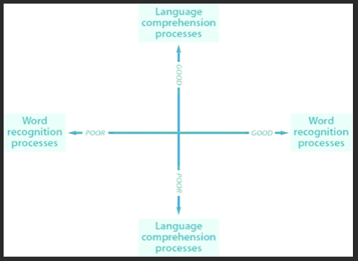*The Simple View of Reading*

**Home Reading**

We expect children to read *at least* three times per week at home, which should be recorded in their individual reading diary. Children who do not read at home or who are identified as at risk of not making their expected progress will be provided with additional reading opportunities with an adult in school.

|  |  |  |
| --- | --- | --- |
|  | Book Type | Rationale |
| Reception & Year 1 | The sound a child is working on | Reinforcing the current learning in school. |
| A previous sound learnt | Revisiting a previously learned sound – targeted to those sounds that assessment shows is least strong. |
| Fiction/non-fiction books | A second book to be taken home to be read to children at home by an adult in order to develop a love of reading and support growing vocabulary. |
| Developing Readers Y2 – Y6 | Colour banded book | These books develop children’s vocabulary and reading skills progressively, allowing children to build confidence and resilience. Assessment information is used to accurately determine the appropriate colour band. Once children are confident readers a reading scheme may be demotivating and stifle interest and a love of reading for ‘real’ books, therefore staff will give careful consideration to each individual child when this transition arises. |
| Library book/Leisure reading | An additional book selected by the child from the classroom selection or library, which can be read independently or with/by an adult, to further promote a love of reading and develop personal preferences. |
| Confident Readers | ‘Free Reader’ | Children will access the school library to choose books to read independently. These books promote a love of reading and allow children to develop personal preferences and explore other genres and formats. |