French: Tuesday 18th January 2021

French Days of the Week

Revision

Can you ask someone how they are in French?
- Comment çava? How are you?
- çava bien – I am fine
- çava très bien – I am very well
- Çava mal – I am poorly
- comme ci comme ça – I am ok or so/so

Watch the following video on French fruits:

https://www.youtube.com/watch?v=6wDTt-4wBsI

- Pick 1 fruit from the video.
- Draw the fruit.
- Label the fruit using the French word.
- Can you label the color of the fruit?

For example
Une pomme

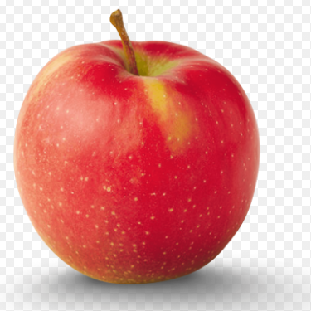
Apple
Vert
Rouge

Days of the Week in French

Watch the video

https://www.bbc.co.uk/teach/class-clips-video/french-ks2-days-of-the-week/zv2jmfr

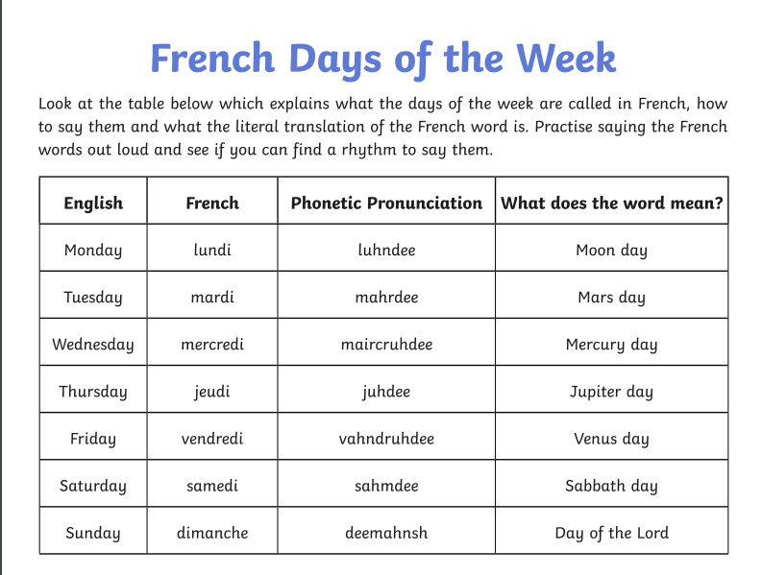

Practise saying the days of the week.

Activity

Can you put the days of the week in order?

- dimanche

- jeudi

- lundi

- vendredi

- samedi

- mardi

- mercredi

