Circle who has the least?
I have £64 I have 64p I have 58p I have £58

Anna has three coins in her hand.

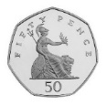
Larry says, “I have more than you because I have a 50 pence coin.”
Is he correct? ____
Explain why.

    
    
    
    



