To recognise adverbs and use them in full sentences.
Spot the adverbs in the word search, then choose your 4 favourites and put them in interesting sentences with adjectives.
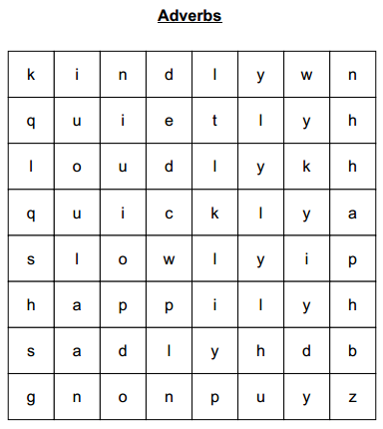

quickly, slowly, loudly,
quietly, kindly, happily, sadly

