Monday 25th January

/wr/ at the beginning of words

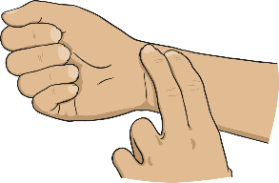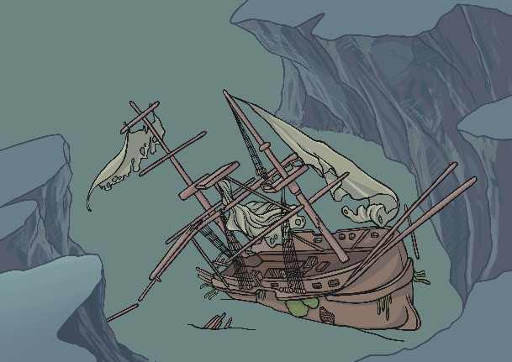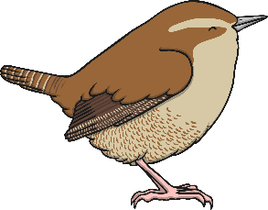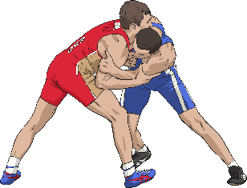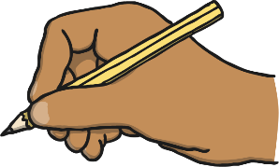

___________________________________________________________________________

___________________________________________________________________________

___________________________________________________________________________

To cover something up.

The opposite of right.

When ideas were put on paper or on a computer by somebody.

To move about quickly.

The past tense of ‘write’.