Monday 1st February
Contractions
Expanded form | Contracted form
can not
It is
did not
could not
would not
 | wasn’t
 | shouldn’t
 | hasn’t

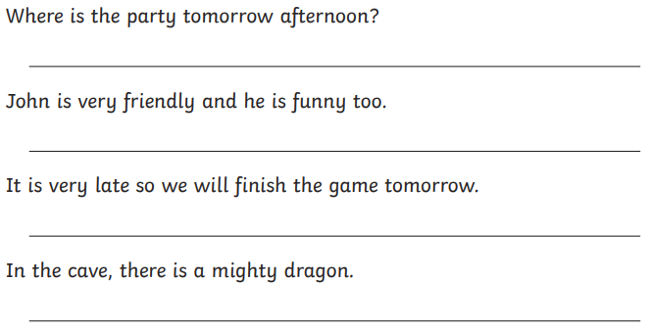

Can you write two sentences of your own using the contractions from the table?

