French: Tuesday 26th January 2021

Months of the year in French

Revision
Can you ask someone how they are in French?
- Comment çava? How are you?
- çava bien – I am fine
- çava très bien – I am very well
- Çava mal – I am poorly
- comme ci comme ça – I am ok or so/so

Days of the week in French:

Practice saying the days of the week to someone in your house.

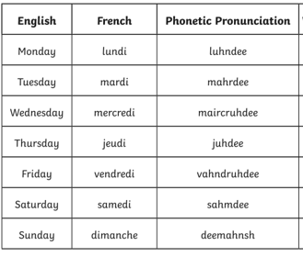

Activity

Go through the attached PowerPoint presentation on Months of the year. Make sure you put it in slide show view so you can hear the sound files.

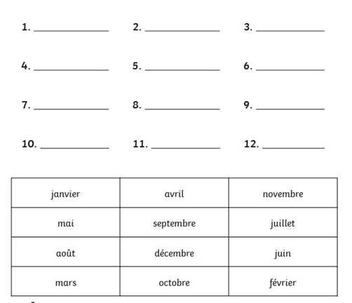
Can you put the months of the year in order?

Can you practice saying them as you write them?

Challenge

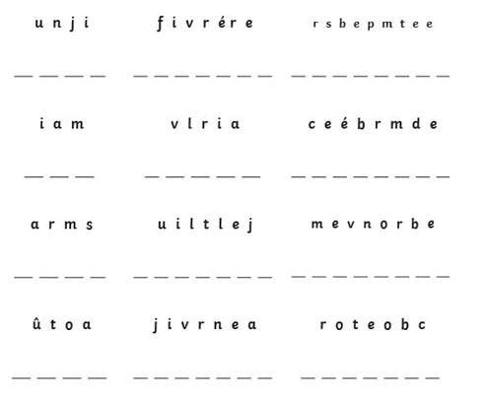
Can you work out the anagrams below to write the correct French month?

