Friday 8th January
Phonics
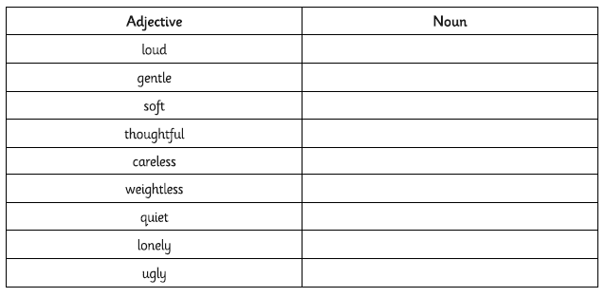
Use the words you have created above. Insert the correct word into the sentence.
