Monday 11th January
Phonics
Write the words to match each of the pictures.
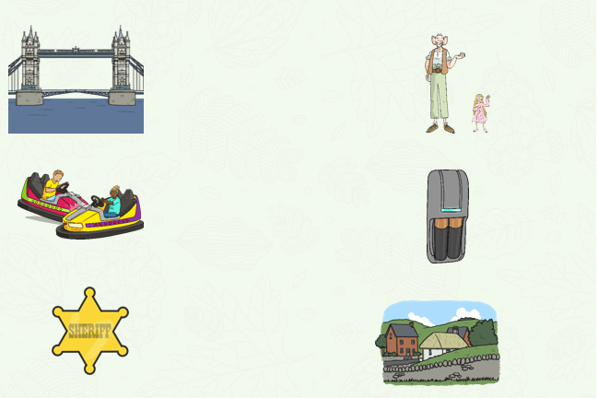
Using the words in the word list below, create your own interesting sentences.

