Wednesday 13th January
Phonics
Re-write the sentences to include an apostrophe for possession.
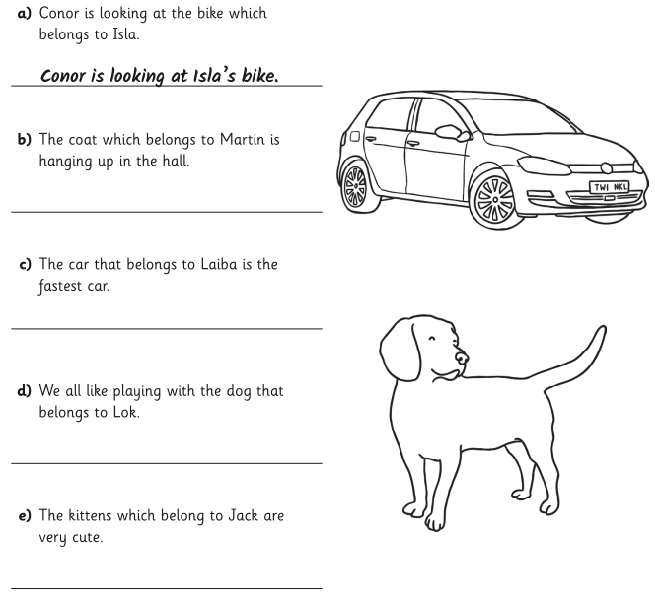
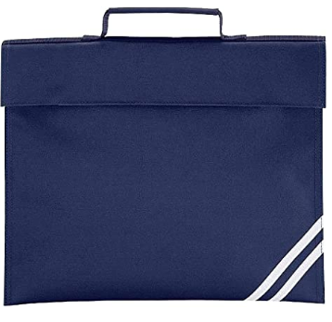
Create your own sentences using possessive apostrophes.

