Thursday 4th February
Phonics - /il/ and /al/ at the end of words

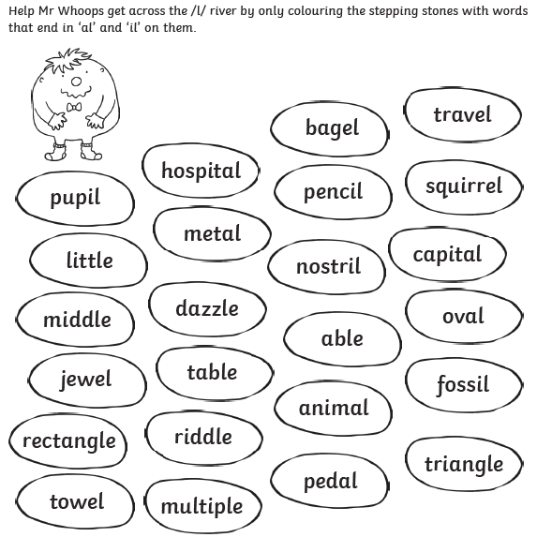
Use the words in the stepping stones to create 4 of your own sentences.

