Tuesday
This week, we are going to write a letter to Salva from his mother.
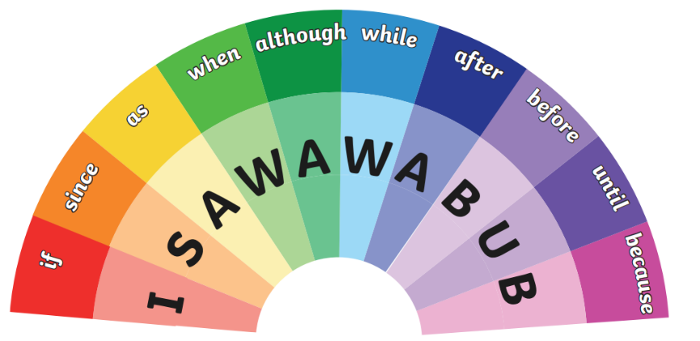
Look at the text below and underline the conjunctions:

Dear Salva,
It feels surreal to be writing this letter to you. When I heard the news that the rebels had gone to your school, my heart broke. All I could think of was whether you were safe.
I wish I could go back to that morning before our lives changed drastically. So I could experience all the little things again, like waking you up, making you breakfast and listening to you bicker with your siblings. I wish I could see your smile and those sparkly eyes, full of mischief and laughter.
I keep thinking about how everything could be different. If I had kept you at home would you still be with me now? I replay every last moment with you in my head because I can’t help but wonder whether I could’ve prevented this. Sadly, deep down, I know that this was all out of my hands.
As each day comes to an end, I know that the likelihood of you coming back to us fades slightly although, my hope keeps growing. I feel it in my bones that you will come back to us Salva.
Keep safe, I love you lots,
Mother
xxx

