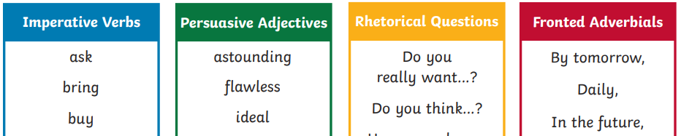
Repetition

Can you underline the key features of a persuasive text? I have included a couple examples above, just to remind you what these features are.

Water for South Sudan
Can you imagine having to walk 2km just for a glass of water? For too long, this has been the sad reality for many children and women, who live in Sudan. It’s time for a change. Make that change happen by supporting Water for South Sudan.
For the past few years, this amazing charity has been supporting people in remote villages. They have created life-changing, sustainable, locally led programs that strengthen individuals, families and communities. No longer will the people of these villages have to trek long distances for dirty water. No longer will these people get sick or die for taking a drink.
Having worked closely with locals, we have helped them drill new wells, improved old wells, and taught them how to maintain them. We have drilled an astonishing 459 new wells. With your help, we will drill more. Each well pumps approximately 1,800 gallons of water per day and serves anywhere from 500 to 1000 people. You can help more people, get clean water by supporting us.
Water for South Sudan believes that by giving to our charity you will be improving the lives of children. No longer will they have to spend hours trekking for dirty water. They will now have the time and opportunity to go to school. Get these children clean water and an education!
Remember: supporting Water for South Sudan means giving a better world for children; a better way of life and a better tomorrow.
What are you waiting for? Make tomorrow happen today. Water for South Sudan.

