Wednesday 27th January
Contractions
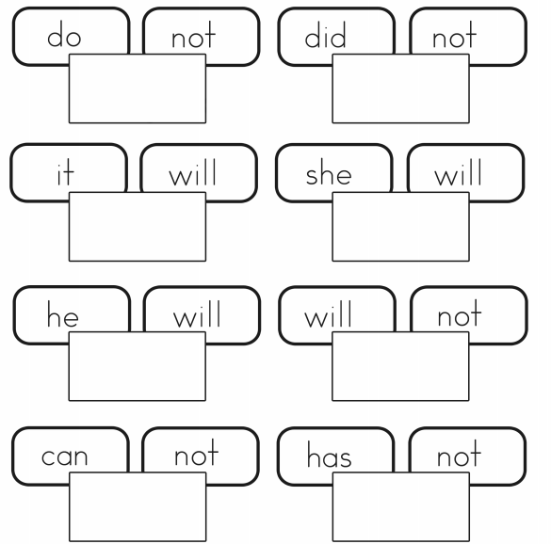
What words can we spot in the text that we can turn into contractions?

