Wednesday 3rd February
Phonics - /el/ at the end of words

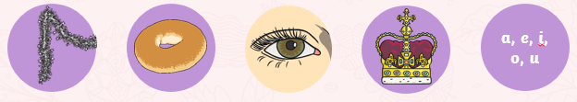

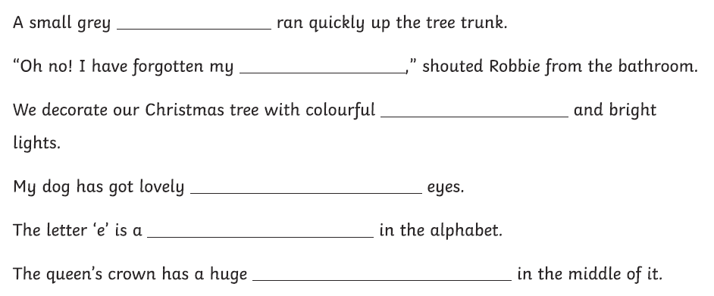

Have a go at using some of the /el/ words in 3 of your own sentences.

