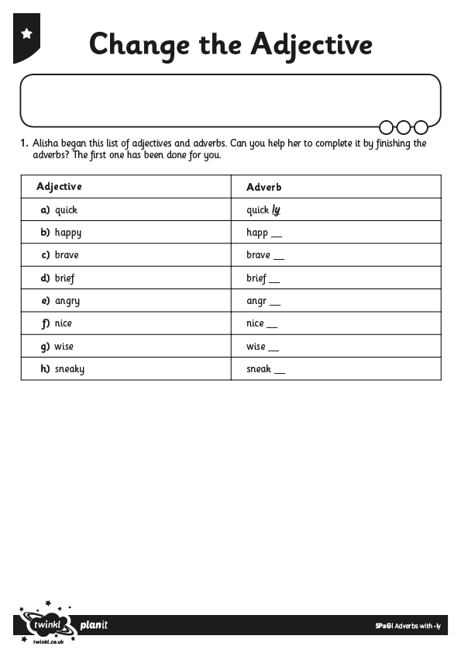

I can add the suffix ly to change an adjective into an adverb.
I can add the suffix ly to words ending in y.

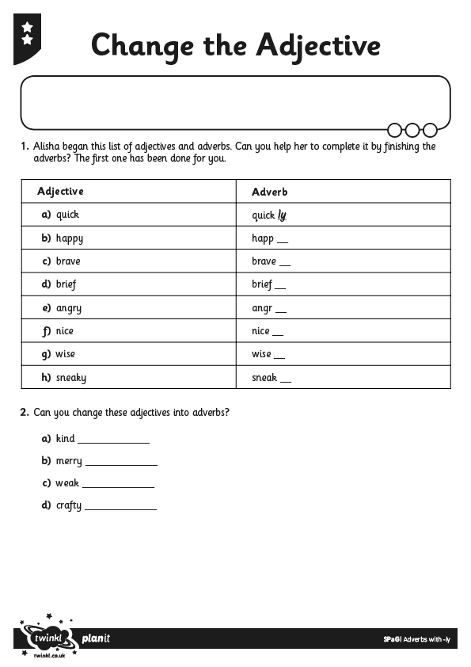

I can add the suffix ly to change an adjective into an adverb.
I can add the suffix ly to words ending in y.

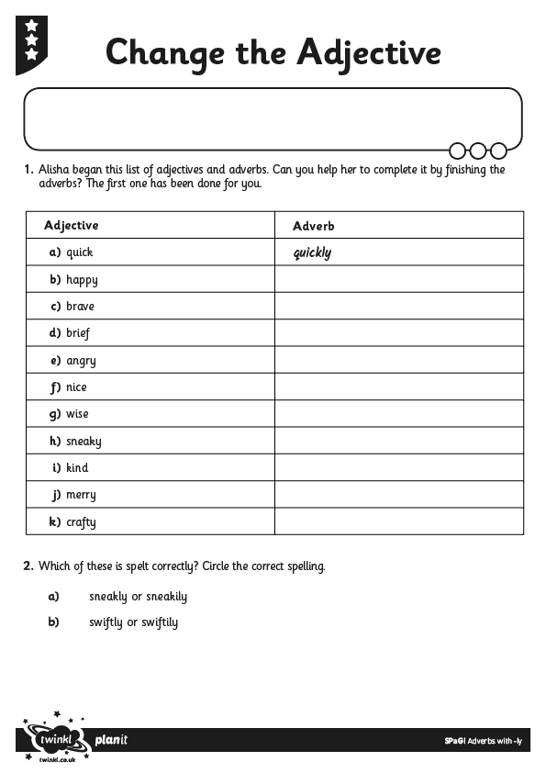
I can add the suffix ly to change an adjective into an adverb.
I can add the suffix ly to words ending in y.

