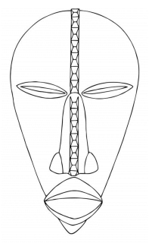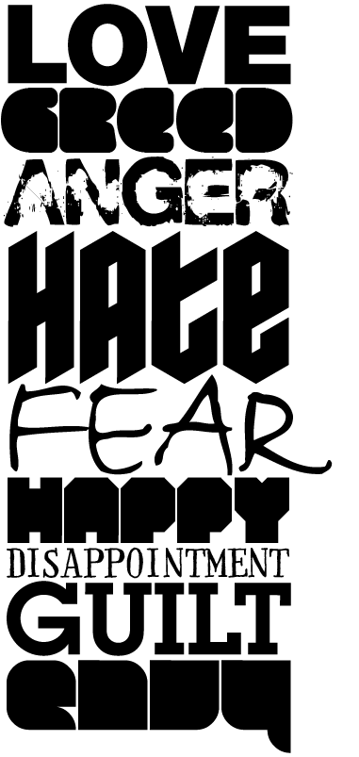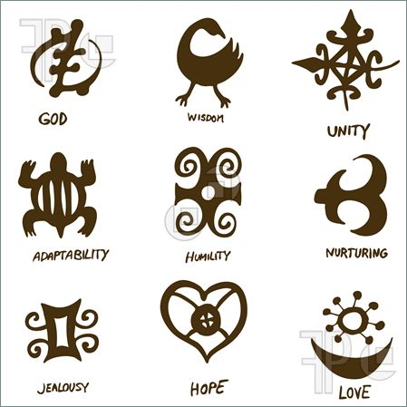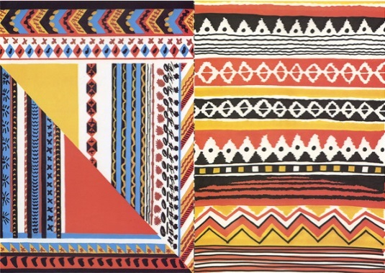 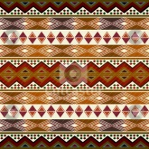

L3- Understand how and why masks are created with some knowledge of the meanings behind some of the symbols.

L4- Create patterns that have been influenced by the African culture and experiment with colour and text.

L5- Think carefully about the patterns, colour and symbols and the composition of them on your mask.

L.O. Investigate the African craft of mask making, how and why they are created.

Explore West African symbols & meanings

1. The masks often express feelings or personal qualities. In the spaces below write a word in a style to express its meaning. For example… 
2. Try to draw two African symbols from below

L.O – To explore a variety of ways to produce a patterned portrait and facial features.

Level 3- use a selection of patterns and colour to decorate the face. Experiment with alternate ways to create facial features.

Level 4- consider the use of pattern, colour and repetition to complete the face.

Level 5- pay close attention to detail, colour, and shape and consider if you want the face to be symmetrical. Use tone throughout your work. You will also use your observational skills to draw the facial feature to have the correct shape and proportion.

L.O – To explore a variety of ways to produce a patterned portrait and facial features.

Level 3- use a selection of patterns and colour to decorate the face. Experiment with alternate ways to create facial features.

Level 4- consider the use of pattern, colour and repetition to complete the face.

Level 5- pay close attention to detail, colour, and shape and consider if you want the face to be symmetrical. Use tone throughout your work. You will also use your observational skills to draw the facial feature to have the correct shape and proportion.

1. In each circle below create a pattern that you could use on your mask. You may want to try some of the patterns above.

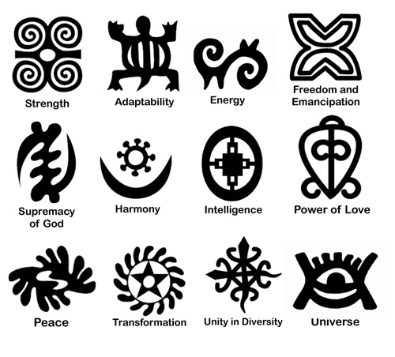

Aim Higher-create your own pattern, think about repetition and how you could use it to create complex patterns

Pencil

1. Pick 4 colours that you will use on your mask.

Aim Higher-create one of your own symbols to put on your mask.

Colour

Pen

5. Add patterns and symbols to your own mask to make it reflect you as a person.

Write **2** stars and a wish about your African mask



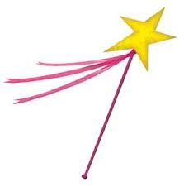

Aim Higher-use similar colours to that of the African patterns.