Thursday 11th February
Phonics – /le/ /el/ /il/ /al/
Circle the correct spelling of each word:
tickal | tickle | tickel
hotal | hotle | hotel
barral | barrle | barrel
abal | able | abel
littal | little | littel
capital | capitle | capitel
channal | channle | channel
petal | petle | petel
squirral | squirrle | squirrel
bottal | bottle | bottel
tunnal | tunnle | tunnel

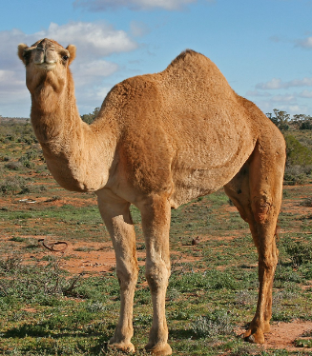
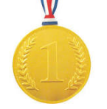
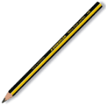

Can you use a word from the table in your own sentence?

