Wednesday 10th February
RE - Allah
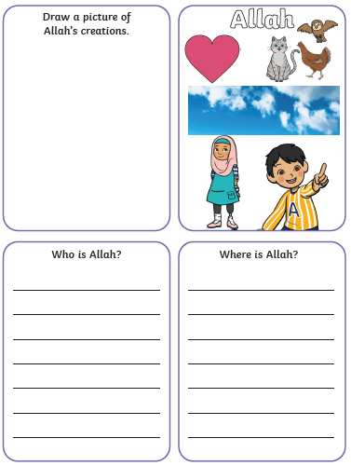
Who do Muslims focus on when they are praying?

Why do you think they do this?

