Thursday 25th February
Phonics – Common Exception Words
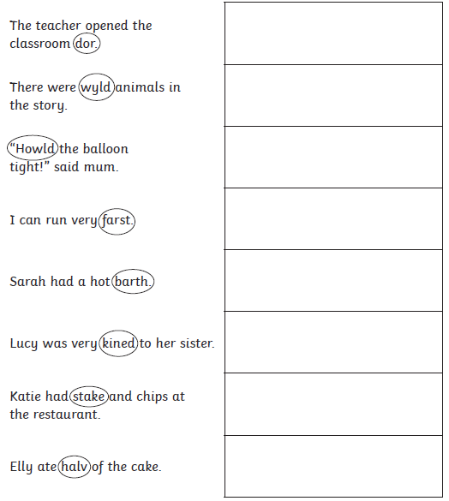
Write a sentence using each of these three Common Exception Words.
What is the same? What is different?
class
grass
pass

