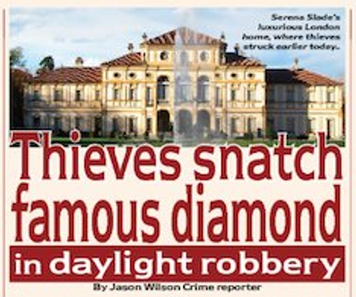

‘I couldn’t believe it when I heard that the diamond had been stolen!’ exclaimed Mr Stone. He continued, ‘Serena is devastated, she doesn’t usually bring her jewellery with us on our travels – particularly the precious champagne diamond!’ It is thought that the jewellery is usually kept within a high security vault inside their Hollywood home. Mr Stone adamantly stated, ‘It must have been an inside job, I just don’t see how the thieves could have possibly gotten through our extremely

The champagne diamond, one of the world’s most famous jewels has been stolen from the London home of the American movie star Jasper Stone and his wife Serena Stone. Police describe this morning’s theft as a bold and daring daylight robbery. Serena was going to wear the diamond at tomorrow’s international film award ceremony, which is held at the lavish Dorchester Hotel. The giant gem which is set inside a spectacular golden necklace got its name because of its pale champagne colour. It has been much sought after by the rich and famous since it was discovered in South Africa in 1906. Jasper Stone bought it for his wife when they got married five years ago for a staggering 2.3million dollars. Mr Stone has described the theft as a sly sneaky inside job. He was reported saying that despite great security, thieves have managed to get inside their home and steal the diamond necklace in broad day light. It is thought that although some staff were in the house at the time, the famous couple were not at home when the incident took place, however this hasn’t been confirmed yet.

high security without help.’ Chief superintendent Andy Campbell who is leading the investigation stated, ‘The diamond had been kept in a strict secure location within the couple’s home and only a few of the staff even knew about it.’

In a closing statement to the press he added, ‘We are working tirelessly to recover the diamond. Luckily the colour, size and exquisite cut makes it almost impossible for the thief to sell it on.’