1)   There were 15 knights who had 3 weapons each. How many weapons did they have altogether?_________

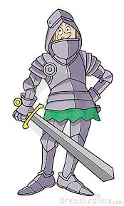

2)  There were 37 Kings who had 5 servants each. How many servants are there altogether?____

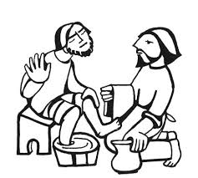

3)  A Queen owns 48 gold coins. How many gold coins would 6 Queen's own?_____



4)  29 Lords live in a Castle. How many Lords would there be if there were 4 Castles?________

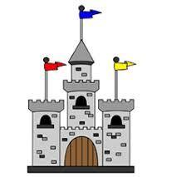

5)  A Knight wears 6 pieces of armour. How many pieces of armour would there be altogether if there were 32 Knights?______

